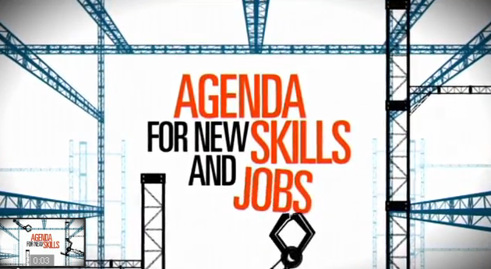
VIDEO: AGENDA DE LAS NUEVAS CUALIFICACIONES Y EMPLEOS.
Listening/reading transcript.
http://www.youtube.com/watch?v=gDTnhtrw2Q8

The European Union set of policy measures agenda for new skills and jobs brings together public employment services, Governments, social partners and the European institutions to achieve a better functioning labour market and more jobs by 2020.

To succeed there is a need for flexible contracts and working arrangements on the labour market.

To be coupled with adequate employment security. Unemployment benefit schemes should motivate people to look actively for work and to create income security while public employment services must provide more targeted support.

Education, training and retraining must equip people with the skills needed today and in the labour market of tomorrow. Investing more resources into anticipating trends will give us a better understanding of tomorrow's skills needs.

Skills and qualifications gained in one EU country need to be recognized in all others. All this will result in a better match between job seekers and job vacancies on the labour market.

European legislation is being constantly reviewed to make sure all workplaces are fairier and safer.

The EU aims for a productive workforce and a dynamic labour markets that generates high-quality sustainable jobs and especially new jobs in both traditional a new fields.

To sustain the current European social model, and our way of life, at least 75 percent of people aged 20 to 64 must work. The agenda of new skills and jobs, a multi-action strategy to increase employment and encourage economic growth brings together all the actors and tools necessary to achieve this goal by 2020.

